Session 7 Managing Groups
Objectives
After completing this module, you will be able to:
- Create groups.
- Manage group membership.
- Apply strategies for using groups.
- Modify groups.
- Manage default groups.

1. Introduction
A group is a collection of user accounts. You can use groups to efficiently manage access to domain resources, which helps simplify network maintenance and administration. You can use groups separately, or you can place one group within another to further simplify administration.
Before you can effectively use groups, you must understand the function of groups and the types of groups that you can create. The Active Directory® directory service supports different types of groups and also provides options to determine the group’s scope, which is how the group can be used in multiple domains.

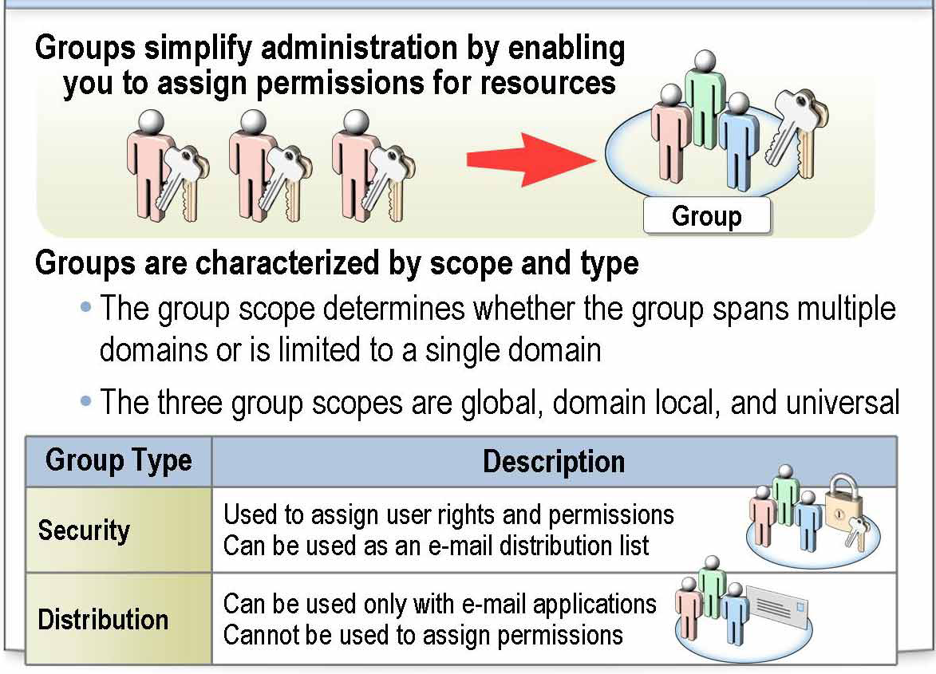
Groups are a collection of user and computer accounts that you can manage as a single unit. Groups:
- Simplify administration by enabling you to grant permissions for resources, once to a group rather than to each user account individually.
- Can be based on Active Directory or local to an individual computer.
- Are characterized by scope and type.
- Can be nested, which means that you can add a group to another group.

2. Types of Group
You use groups to organize user accounts, computer accounts, and other group accounts into manageable units. Working with groups instead of individual users helps simplify network maintenance and administration. There are the following types of groups in Active Directory:
- Security groups
You use security groups to assign user rights and permissions to groups of users and computers. Rights determine what members of a security group can do in a domain or forest, and permissions determine what resources a member of a group can access on the network.
You can also use security groups to send e-mail messages to multiple users. Sending an e-mail message to the group sends the message to all members of the group. Therefore, security groups have the capabilities of distribution groups.

- Distribution groups
You use distribution groups with e-mail applications, such as Microsoft® Exchange, to send e-mail messages to collections of users. The primary purpose of this type of group is to gather related objects, not to grant permissions.
Distribution groups are not security-enabled, meaning that they cannot be used to assign permissions. If you need a group for controlling access to shared resources, create a security group.
Even though security groups have all the capabilities of distribution groups, distribution groups are still required, because some applications can use only distribution groups.
Both distribution and security groups support one of the three group scopes.

Group scopes
The group scope determines whether the group spans multiple domains or is limited to a single domain. Group scopes enable you to use groups to grant permissions. The group scope determines:
- The domains from which you can add members to the group.
- The domains in which you can use the group to grant permissions.
- The domains in which you can nest the group within other groups.
The group scope determines who the members of the group are. Membership rules govern the members that a group can contain and the groups of which a group can be a member. Group members consist of user accounts and other groups.
To assign the correct members to groups and to use nesting, it is important to understand the characteristics of the group scope. There are the following group scopes:
- Global
- Universal
- Domain local

a) Global Groups
A global group is a security or distribution group that can contain users, groups, and computers that are from the same domain as the global group. You can use global security groups to assign user rights and permissions to resources in any domain in the forest.

Characteristics of global groups
The following summarizes the characteristics of global groups:

- Members
• In domain mixed functional level, global groups can contain user and computer accounts that are from the same domain as the global group.
• In native functional level, global groups can contain user accounts and global groups that are from the same domain as the global group.
- Can be a member of
• In mixed mode, a global group can be a member of only domain local groups.
• In native mode, a global group can be a member of universal and domain local groups in any domain and global groups that are from the same domain as the global group.

- Scope
• A global group is visible within its domain and all trusted domains, which include all of the domains in the forest.

- Permissions
• You can grant permissions to a global group for all domains in the forest.

When to use global groups
Because global groups have a forest-wide visibility, do not create them for domain-specific resource access. Use a global group to organize users who share the same job tasks and have similar network access requirements. A different group type is more appropriate for controlling access to resources within a domain.

b) Universal Groups
A universal group is a security or distribution group that can contain users, groups, and computers from any domain in its forest. You can use universal security groups to assign user rights and permissions to resources in any domain in the forest.

Characteristics of universal groups
The following summarizes the characteristics of universal groups:
- Members
• You cannot create universal groups in mixed mode.
• In native mode, universal groups can contain user accounts, global groups, and other universal groups from any domain in the forest.
- Can be a member of
• The universal group is not applicable in mixed mode.
• In native mode, the universal group can be a member of domain local and universal groups in any domain.

- Scope
• Universal groups are visible in all domains in the forest.

- Permissions
• You can grant permissions to universal groups for all domains in the forest.

When to use universal groups
Use universal groups to nest global groups so that you can assign permissions to related resources in multiple domains. A Windows Server 2003 domain must be in Windows 2000 native mode or higher to use universal groups.

c) Domain Local Groups?
A domain local group is a security or distribution group that can contain universal groups, global groups, other domain local groups that are from its own domain, and accounts from any domain in the forest. You can use domain local security groups to assign user rights and permissions to resources only in the same domain where the domain local group is located.

Characteristics of domain local groups
The following summarizes the characteristics of domain local groups:
- Members
• In mixed mode, domain local groups can contain user accounts and global groups from any domain. Member servers cannot use domain local group in mixed mode.
• In native mode, domain local groups can contain user accounts, global groups, and universal groups from any domain in the forest, and domain local groups that are from the same domain as the domain local group.
- Can be a member of
• In mixed mode, a domain local group cannot be a member of any group.
• In native mode, a domain local group can be a member of domain local groups that are from the same domain as the domain local group.
- Scope
• A domain local group is visible only in the domain that the domain local group belongs to.
- Permissions
• You can assign permissions to a domain local group for the domain that the domain local group belongs to.

When to use domain local groups
Use a domain local group to assign permissions to resources that are located in the same domain as the domain local group. You can place all global groups that need to share the same resources into the appropriate domain local group.

d) Local Groups?
*****************************illegal for non-trainer se******************************
A local group is a collection of user accounts or domain groups created on a member server or a stand-alone server. You can create local groups to grant permissions for resources residing on the local computer. Windows 2000 or Windows Server 2003 creates local groups in the local security database. Local groups can contain users, computers, global groups, universal groups, and other domain local groups.
Because groups with a domain local scope are sometimes referred to as local groups, it is important to distinguish between a local group and a group with domain local scope. Local groups are sometimes referred to as machine local groups to distinguish them from domain local groups.

Characteristics of local groups
The following summarizes the characteristics of local groups:
- Local groups can contain local user accounts from the computer where you create the local group.
- Local groups cannot be members of any other group.

When to use local groups
The following are guidelines for using local groups:
- You can use local groups only on the computer where you create the local groups. Local group permissions provide access to resources only on the computer where you created the local group.
- You can use local groups on computers running currently supported Microsoft client operating systems and member servers running Windows Server 2003. You cannot create local groups on domain controllers, because domain controllers cannot have a security database that is independent of the database in Active Directory.
- Create local groups to limit the ability of local users and groups to access network resources when you do not want to create domain groups.

Where to Create Groups
In Active Directory, groups are created in domains. You use Active Directory Users and Computers to create groups. If you have the necessary permissions, and by correctly associating users and computers with groups, you can create groups in any other domain in the forest, or an organizational unit.
Besides the domain in which it is created, a group is also characterized by its scope. The scope of a group determines:
- The domain from which members can be added.
- The domain in which the user rights and permissions assigned to the group are valid.

Choosing a domain or organizational unit
Choose the particular domain or organizational unit where you create a group based on the administration requirements for the group.

For example, suppose your directory has multiple organizational units, each of which has a different administrator. You may want to create global groups in those organizational units so that those administrators can manage group membership for users in their respective organizational units.

If groups are required to control access outside the organizational unit, you can nest the groups within the organizational unit into universal groups (or other groups with global scope) that can be used elsewhere in the forest. It may be more efficient to nest global groups if the domain functional level is set to Windows 2000 native or higher, the domain contains a hierarchy of organizational units, and administration is delegated to administrators at each organizational unit.

Naming Guidelines for Groups
In Active Directory, there are many security and distribution groups. The following naming conventions help you manage these groups. Organizations develop their own naming conventions for their security and distribution groups. A group name should identify the scope, type, who the group was created for, and what permissions the group can have.

a) Security group
Consider the following in defining a naming convention for security groups:
- Scope of security groups
Although the group type and scope are displayed as the group type in Active Directory Users and Computers, organizations often incorporate the scope in the naming convention of the group name.
For example, Northwind Traders identifies the scope of security groups by adding a first letter to the group name:
• G IT Admins - G for global groups
• U All IT Admins - U for universal groups
• DL IT Admins Full Control - DL for domain local groups

- Ownership of the security group
The name for any domain-level security group, whether universal, global, or domain local, should clearly identify ownership by including the name of the division or team that owns the group.
The following is an example of a naming convention that Northwind Traders might use to identify group ownership:
• G Marketing Managers
• DL IT Admins Full Control

- Domain name
Upon client request, the domain name or abbreviation is placed at the beginning of the group name. For example:
• G NWTraders Marketing
• DL S.N.MSFT IT Admins Read

- Purpose of the security group
Finally, in a name, you can include the business purpose of the group and maximum permissions the group should ever have on the network. This naming convention is more applicable to domain local or local groups.

The following is an example of a naming convention that Northwind Traders might use to identify the purpose of the security group. Northwind Traders uses a descriptor to identify the maximum permissions a group should ever have on the network. For example:
• DL IT London OU Admins
• DL IT Admins Full Control

b) Distribution groups
Because security groups are mostly used for network administration, only the personnel administering the network must use the naming convention. End users use distribution groups, so the naming convention must be relevant to an end user.

When defining a naming convention for distribution groups consider the following:
- E-mail names
• Length. Use a short alias name. To conform to current downstream data standards, the minimum length of this field is three characters, and the maximum length is eight characters.
• Offensive words. Do not create distribution groups with words that may be considered offensive. If in doubt, do not use the word.
• Allowed characters. You can use all ASCII characters. The only allowed special characters are the hyphen (-) and underscore (_).
• Special designations. Do not use the following character combinations or distributions groups:
• An underscore (_) as the beginning character of the group name of the alias name
• A first name or combination of first name and last name that may easily be confused with a user account name

- Display names
• User alias names. For standardization purposes, do not include a user’s alias name as part of a display name (for example, Sfine Direct Reports).
Include the full name (for example, Suzan Fine.s Direct Reports).
• Offensive words. Do not create distribution groups with words that may be considered offensive.
• Social discussions. Distribution groups for social discussions should not be allowed, because public folders are a more efficient means of transmitting and storing high-volume communications associated with social discussions. Because a post is visible to multiple users, both network traffic and data storage are minimized if you use public folders instead of corporate distribution groups.
• Length. The maximum length of this field is 40 characters. Abbreviations are acceptable as long as the meaning is clear.
• Style. Do not capitalize the entire description, but capitalize the first letter in the display name. Use proper punctuation and spelling.
• Top of the address book. Do not use the word A, numbers, special characters (especially quotes), or a space to begin a description. This makes it appear at the top of the address book. The address book should begin with individual user names starting with A.
• Special characters. Slashes (/) are acceptable in display names, but do not use them in front of server names. Do not use more than one apostrophe (.) and do not use the following special characters: " * @ # $ % | [ ] ; < > =

- Ownership
There can be a maximum of five co-owners of a single distribution group.

c) Local groups
A local group name cannot be identical to any other group or user name on the local computer being administered. A local group name cannot consist solely of periods (.) or spaces. It can contain up to 256 uppercase or lowercase characters, except the following: " / \ [ ] : ; | = , + * ? < >

Note
Your environment may not use these guidelines but will most likely use some group naming conventions.

How to Create a Group
In most corporate environments, you will create groups in domains. Active Directory has security and tracking features that limit the addition of users to groups. Active Directory also gives corporations the flexibility to use groups on member servers. Corporations often have servers that are exposed to the Internet and want to use local groups on member servers rather than domain local groups to limit the exposure of internal groups and group members.

Procedure for creating a group in a domain
To create a group in an Active Directory domain:
1. In Active Directory Users and Computers, in the console tree, right-click the folder to which you want to add the group, point to New, and then click Group.
2. In the New Object . Group dialog box, in the Group name box, type the name of the new group.
3. Under Group scope, click the group scope for the new group.
4. Under Group type, click the group type for the new group.

Note
To perform this procedure, you must be a member of the Account Operators group, Domain Admins group, or the Enterprise Admins group in Active Directory, or you must be delegated the appropriate authority. As a security best practice, consider using Run as to perform this procedure.

Important
If the domain in which you are creating the group is set to the domain functional level of Windows 2000 mixed, you can select only security groups with domain local or global scope.

To create a local group on a member server:
1. In Computer Management, in the console tree, click Groups.
2. On the Action menu, click New Group.
3. In the New Group dialog box, in the Group name box, type a name for the new group.
4. In the Description box, type a description for the new group.
5. To add one or more users to a new group, click Add.
6. Click Create, and then click Close.

To perform this procedure, you must be a member of the Power Users group or the Administrators group on the local computer, or you must be delegated the appropriate authority. If the computer is joined to a domain, members of the Domain Admins group might be able to perform this procedure.
As a security best practice, consider using Run as to perform this procedure.

Procedure for deleting a group
To delete a group:
1. In Active Directory Users and Computers, in the console tree, click the folder that contains the group.
2. In the details pane, right-click the group, and then click Delete.
To perform this procedure, you must be a member of the Account Operators group, Domain Admins group, or the Enterprise Admins group in Active Directory, or you must be delegated the appropriate authority. As a security best practice, consider using Run as to perform this procedure.

Managing Group Membership
Because many users often require access to different resources throughout an organization, administrators may have to grant membership to groups that reside in Active Directory or on local computers.
When adding members to or removing members from groups in Active Directory, an administrator can open Active Directory Users and Computers, click on a user account, drag it to the desired group, and drop the user account onto the group. This action quickly adds the user account to the group.
When adding members to or removing members from groups on a local computer, an administrator can use Computer Management to change group membership on the local computer.

The Members and Member Of Properties
Tom, Jo, and Kim are members of the Denver Admins global group. The global group Denver Admins is a member of the domain local group Denver OU Admins.

Sam, Scott, and Amy are members of the Vancouver Admins global group. The global group Vancouver Admins is a member of the domain local group Denver OU Admins.
The following table summarizes the information:.
User or Group | Members | Members Of
Tom, Jo, Kim  Denver Admins | Tom, Jo, Kim | Denver Admins  Denver OU Admins
Sam, Scott, Amy  Vancouver Admins | Admins Sam, Scott, Amy | Denver OU Admins
Denver OU Admins | Denver Admins  Vancouver Admins

By using the Members and Member Of properties, you can determine groups that the user belongs to and what groups that group belongs to.

Best Practices for Managing Groups
Consider the following best practices for managing groups:
! Create groups based on administrative needs. When you create a group based on a job function and another person takes over that job, you only need to change the group membership. You do not need to change all permissions that are granted to the individual user account. Because of this, it is sometimes advantageous to create a group that has only one member.
! Use local groups to give users access to resources on local computers when the computer is not a member of a domain.
! If you have multiple groups to which you can add user accounts, add user accounts to the group that is most restrictive. However, ensure that you grant the appropriate user rights and permissions so that users can accomplish any required task.
! Whenever a default group enables users to accomplish a task, use the default group instead of creating a new group. Create groups only when there are no default groups that provide the required user rights and permissions.
! Use the Authenticated Users group instead of the Everyone group to grant most user rights and permissions. Using this group minimizes the risk of unauthorized access, because Windows Server 2003 adds only valid user accounts to members of the Authenticated Users system group.
! Limit the number of users in the Administrators group. Members of the Administrators group on a local computer have Full Control permissions for that computer. Add a user to the Administrators group if the user will perform only administrative tasks.
! Your organization must equally trust all personnel that are members of the Administrators, Power Users, Print Operators, and Backup Operators groups. Some default user rights assigned to specific default local groups may allow members of those groups to gain additional rights on your computer, including administrative rights.

***********

